Day in the Life of the Hudson River 10/14/22 Data
CHELSEA BOAT LAUNCH
RIVER MILE: 65
Hudson River Salt Front: ~ RM 52
Wappingers Jr. High School - Rosellen Hardt
25 students 7th grade and 4 teachers total
1 DEC Fisheries Staff Support
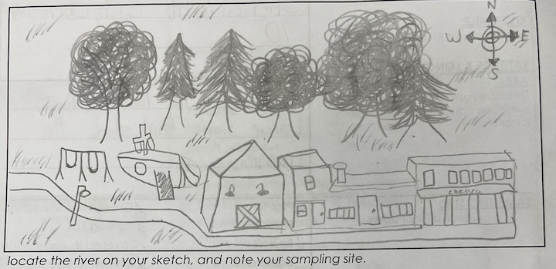
Location: Chelsea Boat Launch, Wappinger Falls, Dutchess County, NY
Area: Rocky, sandy beach for core samples and seining, dock for chemistry
Surrounding Land Use: 25% Urban/Residential, 15% forested, 10% Beach; 50% Industrial/Commercial
Sampling Site: Pier with beach area, wood bulkhead, grassy, parking lot, shoreline covered in vegetation, riprap shoreline, concrete docking in area
Shoreline: 50% muddy; 50% rocky
River Bottom: rocky
Plants in water - none
ITEM | Time | Reading |  |  |  | Comments
Physical
Air Temperature: | NR | ºC |  | ºF
Wind Speed: | NR
Weather Today: | NR
Weather Previous:
Tides | NR
Water Temperature | 10:45 AM | 15º C |  | º F
Turbidity - long sight tube | 9:30 AM  10:12 AM  11:03 AM | 52.6 cm  35.8 cm  45.8
Chemical
Salinity- | NR
DO – NR method  *4 readings all the same each time | Time | Temp |  | ppm DO |  | % saturation
DO – NR method  *4 readings all the same each time | 9:45 AM  10:26 AM  12:35 PM  1:05 PM | 13 ºC  15 ºC  10 ºC * LOW  10 ºC *LOW |  | 10 ppm  8 ppm  8 ppm avg  9 ppm avg |  | 100%  80%  70%  80%
pH – NR method | 9:22 AM  10:10AM  11:00 AM  12:40 PM | 7.5,7.0, 7.0  8.0, 8.0, 8.0  7.5, 8.0. 7.5  7.5,8.0, 8.0 |  | 7.2 avg  8.0 avg  7.7 avg  7.8 avg
Biological
Fish & Macros -  4 seines:  9:30 –2 species, 7 total  10:15 -3 species, 11total  11:15–3 species, 13 total  12:45- 1 species, 5 total | Number | Name |  | Length of longest |  | Length of Shortest
 | 13 | Banded Killisifh
 | 6 | Spottail Shiner
 | 1 | Bluegill sunfish
 | 2 | White perch
 | 9 | Blueback Herring
Fish Total | TOTAL: 31 | DIVERSITY: 5
Macroinvertebrates | Number | Name |  | Length of longest |  | Length of smallest
9:30 AM | 1 | Blue crab |  | Male
10:15 AM | 3 | Blue crab |  | Male
Macroinvertebrate Totals | TOTAL: 4 | Diversity: 1
Boat Traffic
Commercial | 9:00AM | White |  | Northbound |  | Light
Recreational | 12:47 PM | White |  | NR |  | Light

